**Java Collection Framework**

Student’s Name

Institutional Affiliation

Course

Instructor’s Name

Date

**ABSTRACT**

**This research paper investigates the Java Collection Framework (JCF), which is a fundamental toolset in Java programming. It is mainly used to manage object collections. The paper explores its evolution, significance in software engineering and the challenges that it presents. The literature review focuses on its development in Java 12 and its practical applications. Its significant classes such as HashMaps, ArrayLists and LinkedLists are highlighted.**

**Key Words – Java Collection Framework, JCF, Java, Java 12, Java 14, Big Data, Microservices, Cloud Computing & IEEE.**

1. **INTRODUCTION**

Java Collection Framework, JCF, is an important toolkit in Java programming as it provides a rich set of data structures and classes for managing a collection of objects [1]. This principle is very crucial in object-oriented programming. JCF facilitates the storage and manipulation of a wide range of collections of objects such as lists, sets, queues and maps. Developers in particular like to rely on the Java collection framework for its efficiency and simplicity [1]. This research paper aims to delve deep into the evolution of the Java collection framework. The paper will also focus on the relevance of the framework in the modern software development landscape. While at this, the challenges associated with the framework will also be looked at. Finally, the paper will answer the question of how the Java Collection Framework has evolved to address modern software development.

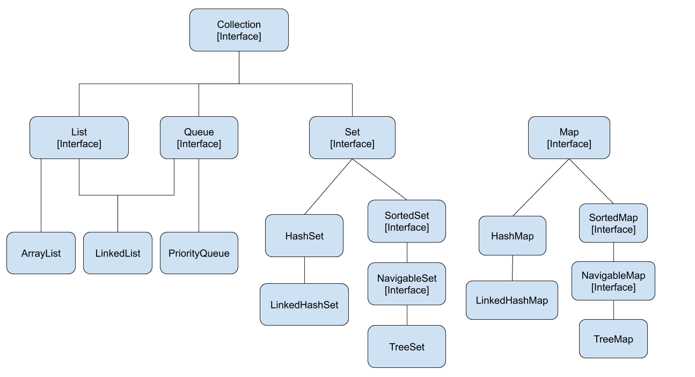

1. **LITERATURE REVIEW**

The Java Collection Framework (JCF) is a key toolset in Java programming, providing a broad range of data structures required for effective object-oriented programming [1]. JCF, which was introduced with Java 12, provides a standardized technique for dealing with collections of objects, facilitating data processing in a wide range of applications, from simple programs to big corporate systems [1]. HashMaps, ArrayLists, and LinkedLists have become essential in modern Java development [3]. As Java evolves, the JCF adapts, improving aspects like immutability and addressing modern software engineering needs. Its importance extends to Big Data, microservices, and cloud computing applications, where its flexibility and efficiency are critical in data processing, storage, and retrieval [2].

1. **METHODOLOGY**

The systematic literature review (SLR) technique is used in this study to evaluate the evolution, significance, and issues connected with the Java Collection Framework (JCF). The literature search includes prominent academic sources such as IEEE Xplore, ACM Digital Library, and SpringerLink, as well as terms like "Java Collection Framework," "Collections in Java," and "Java Data Structures." Scholarly articles, conference papers, and relevant documentation released after Java 12 are prioritized for inclusion. The screening procedure includes a thorough examination of titles and abstracts to ensure compatibility with the study objective. Selected papers are subjected to a comprehensive full-text review to ensure their relevance and quality. Data extraction entails collecting information on the framework's evolution, applications, and difficulties in a methodical manner.

1. **DEVELOPMENT**

Java Collection Framework gained its significance in the early days of Java, it came with Java 12 [3]. The framework consolidated a collection of classes into a single unified framework. It brought about standardization on how to handle different data structures using Java. The standardization itself then resulted in the streamlining of data manipulation. This paved the way for future developments. It has enabled Java to be used in different software domains. The framework’s core classes include HashMaps, ArrayLists and LinkedLists [3]. These have become essentials in modern Java programming. The significance of this is that developers can focus on their application's logic rather than looking for efficient ways to store, retrieve and manipulate data in their application. Through this principle, data manipulation in Java applications has become standardized and more efficient. This not only increases the performance of the application but also enables easier maintenance and room for scaling [3].

The framework continued to evolve with the release of Java 14. This release brought about a substantial improvement to the immutability features of the framework. The release introduced the “of” factory methods that are used to create immutable collections. This was a significant enhancement to the framework. It enables data consistency and safety in different applications, especially multi–thread applications. This makes them crucial in modern software development. The updates continue to improve both the language and the framework as well as libraries. This makes the Java Collection Framework more relevant and valuable in modern software engineering.

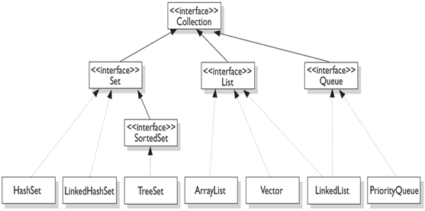

1. **APPLICATION IN MODERN TECHNOLOGY**

The relevance of the Java Collection Framework in modern technology cannot be underestimated. Its relevance is particularly in the fields of Big Data, Microservices as well and Cloud Computing. This is because the framework aligns seamlessly and caters for the needs of modern technology.

1. **Big Data**

In the modern world, decision-making for several organizations is shaped by Big Data. To handle and make sense of big data, which simply refers to a collection of information from various sections of an organization. The data needs to be filtered, organized and then analyzed; a conclusion needs to be drawn from the output of the analysis. The Java Collection Framework plays a pivotal role in contributing to the development of technologies used to achieve that. A practical example is in technologies such as Hadoop and Spark [2]. These technologies have been developed through the use of the Java Collection Framework. The Framework significantly enhances data processing capabilities [2].

Such applications demand versatility, the Java Collection Framework is adaptable and efficient making it the most appropriate for this particular use case. It allows for the storage and analysis of vast datasets that can range from anything such as sales over 10 years to daily temperature fluctuations. Critical data processing operations in distributed systems rely on the Java Collection Framework’s robust support for data manipulation. An example of a use case is in the context of Hadoop’s MapReduce Paradigm. In this case, the Java Collection Framework handles data processing efficiently during the reduction phase. Based on this ability, the framework remains a linchpin in the domain of applications that are data intensive.

1. **Cloud Computing**

The modern world has been revolutionized by the capabilities of cloud computing. The big tech players in the industry all have a cloud service providing to tap into the ever-growing cloud computing,g market. Currently, the market leaders are Amazon Web Services, (AWS) developed by Amazon, Microsoft Azure which is developed by Microsoft and Google Cloud Platform (GCP). All these cloud computing providers have integrated the Java Collection Framework into their software development kits (SDK) and various services offered on the platform. AWS and Azure being at the forefront, utilize the Java Collection Framework to simplify data management for developers crafting applications intended for cloud deployment. This is evident when storing data in AWS using the S3 bucket. For data to be stored in the buckets, Java Collection Framework is used, it ensures accurate storage and retrieval which is desired by developers.

Another example of the application of the framework in cloud computing is in NoSQL databases such as Mongo DB. Since such databases store information as documents, a key–value pair is used. To ensure consistency dlopers leverage the functionality of the Java Collection Frameworksimplifyreamline and simply the storage and retrieval processes in the cloud environment.

1. **Microservices**

Modern technology relies on distributing its goals to achieve their goal. Distributed systems are preferred by developers as they are easier to develop and maintain. They also offer other advantages such as allowing for the removal or addition of a given module without affecting the entire system [4]. This gives rise to microservices which can be defined as sections of a bigger application that exist separately and each has a specific function. Microservices architecture advocates for the creation of lightweight independently deployable components. These components necessitate efficient data sharing and management, which is where the Java Collection Framework comes in. The Java Collection Framework due to its versatility and high – performance seamlessly integrated into microservices development.

The framework plays a pivotal role in streamlining data sharing and access between various services. The framework offers efficient storage and retrieval capabilities [4]. This contributes to the overall effectiveness of microservices-based applications. Modern software development increasingly embraces microservices as a fundamental architectural approach to application development. In this domain, the adaptability of the Java Collection Framework makes it a fundamental part. Its versatility makes it an indispensable tool in modern technology [4].

1. **Distributed Caching**

Distributed caching improves the performance and scalability of various applications. The framework plays a crucial role by offering essential tools that can be used to efficiently manage and cache data. In the framework, this is achieved by two collections, the ConcurrentHashMaps and Guava Cache. ConcurrentHashMaps is designed for concurrent access. This makes it applicable in distributed caching scenarios. This is achieved by allowing multiple nodes and instances to access and modify the cache at the same time. Through the ConcurrentHashMaps a thread–safe implementation is achieved that allows for efficient and synchronized access to the cache. Guava Cache on the other hand is based on the Google Guava library. It allows for a flexible and configurable caching mechanism. It is suitable for situations where a fine – grained control over caching is essential.

1. **CHALLENGES**

Despite its several use cases and advantages, the framework faces a lot of challenges in the context of software development. One challenge the framework faces is the lack of built–in support for persistent data structures. These persistent data structures enable applications to store and produce historical versions of data. Such data structures are crucial in applications such as version control systems. This is because Java's standard collection classes do not support persistent data structures. This forces developers to look for alternatives such as creating custom solutions or relying on third–party libraries. These increase complexity and are potential sources of error when running the program and can significantly affect performance.

The other challenge has to do with parallelism. Parallelism in Java refers to the division of a problem into subproblems and solving each one of them concurrently then combining the result. Java only offers the ‘java.util.concurrent’ package for concurrent data structures. This however is only applicable in some operations and not all. Not all standard collections are parallelizable. An example is when iterating over elements in a List, where each element requires a complex operation, the benefits of multi–core processors are not fully realized. This creates performance-related issues making the framework not beneficial to multi–thread applications [4].

The framework also experiences a performance overhead. In its application, there might be some collection classes that may incur performance overhead in scenarios where elements are of a large number. Due to the locking mechanism that is likely to be experienced by operations that synchronize collections. Furthermore, the framework may be inefficient for large datasets. For extremely large datasets, where resizing of collections is frequently required the framework may be inefficient. This inefficiency is likely to impact the overall performance of applications dealing with large datasets. Lastly, the framework brings about memory overhead in applications that implement the Map interface. A higher memory overhead is undesired in memory–constrained environments or in scenarios where minimizing memory is necessary.

1. **CONCLUSION**

In conclusion, the Java Collection Framework is an integral and enduring component in Java Programming. It showcases its resilience and adaptability in the ever-changing technological landscape of software development. The Java Collection Framework was introduced in Java 12 and since then it has consistently proven its application in development. It continuously aligns and contributes to modern trends such as Cloud Computing and Big Data. The continued prevalence of the framework is a testament to its capacity to meet the ever-evolving needs of the software development community. Its integration with contemporary technologies has been exemplified by its application in Cloud Computing. Its application in tools such as Hadoop and Spark has shown its practical application in data management. Its versatility remains a critical asset for organizations and businesses relying on its robust solutions for efficient data management and analysis.

However, it's crucial to highlight its limitations. One notable limitation is the lack of explicit parallelism. Parallelism is becoming increasingly vital in the context of multi–threaded applications. The absence of native parallel processing support poses a challenge to the optimization of the performance of concurrent and parallel computing scenarios. This limitation calls for additional strategies that come with the cost of potentially introducing complexities in the implementation of given applications. Despite this limitation, the framework remains a stalwart presence in Java programming as it can offer a robust foundation for developers to build upon.

**VIII. REFERENCES**

[1] Horstmann, C. S. (2019). Core Java Volume I - Fundamentals (11th ed.). Pearson.

[2] Jules, S., & Anderson, M. (2019). Big Data Processing with Hadoop. O'Reilly Media.

[3] Oracle. (2020). The Java™ Tutorials - Collections. Oracle Documentation.

[4] Vohra, A. (2020). Java Microservices. Apress.